**EXPERIMENT 14**

**AIM:**Design PDA for the input a^nb^n

**Design and Output:**

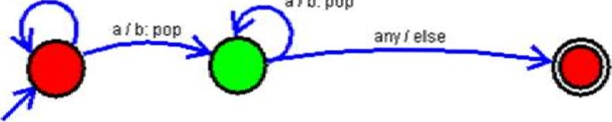

alb:

pop

